Heath Hayes & Wimblebury

Parish Council

You are hereby summoned to a meeting of the Parish Council.

To be held on Wednesday 2nd October 2019.

Commencing 7.30 pm

Hayes Green Community Centre, Heath Way, Heath Hayes.

A G E N D A.

Public Participation and Chair’s Announcements. The first 30 minutes are set aside for the public to raise issues or to ask questions.

Please note the meeting for the Hayes Green Community Centre (7.20pm), which will precede this meeting.

1. Apologies. Consideration of acceptance of any apologies received in writing before the meeting.

2. Declarations of Interest and Dispensations on Agenda Items.

3. To Approve the Minutes of the meeting held on 4th September 2019 and consideration of any matters arising not on the agenda.

4. Planning.
4.1 Applications dealt with by Planning Committee.
4.2 Decisions reported by Cannock Chase Council.

5. Grant Aid – January 2020. Update on current position.

6. Remembrance Events. Present arrangements.

6.1 Wimblebury War Memorial on Sunday 3rd November.

6.2 Heath Hayes Memorial Gates on Sunday 10th November.

7. Newsletter. Consideration of approval of draft issue.

8. Cannel Mount. Consideration of current position.

9. Christmas Lights. Current position and future plans including reinstating the Christmas Lights Competition.

10. Environment issues.

10.1 Open Spaces. Report from Committee.

10.2 Consideration of seconding proposal from Hednesford Town Council to the Staffordshire Parish Councils’ Association regarding a Climate Emergency Declaration.

10.3 Litter. Report on present position and future plans.

11. Dementia Friendly issues in the area. Current position and future plans.

12. How to deal with miscellaneous tasks for the benefit of the area.

13. To note the incoming and outgoing correspondence.

14. Accounts for Payment – As per separate report.

15. Items for Information or Future Agendas only.

16. Date of Next Meeting – Wednesday 6th November 2019.

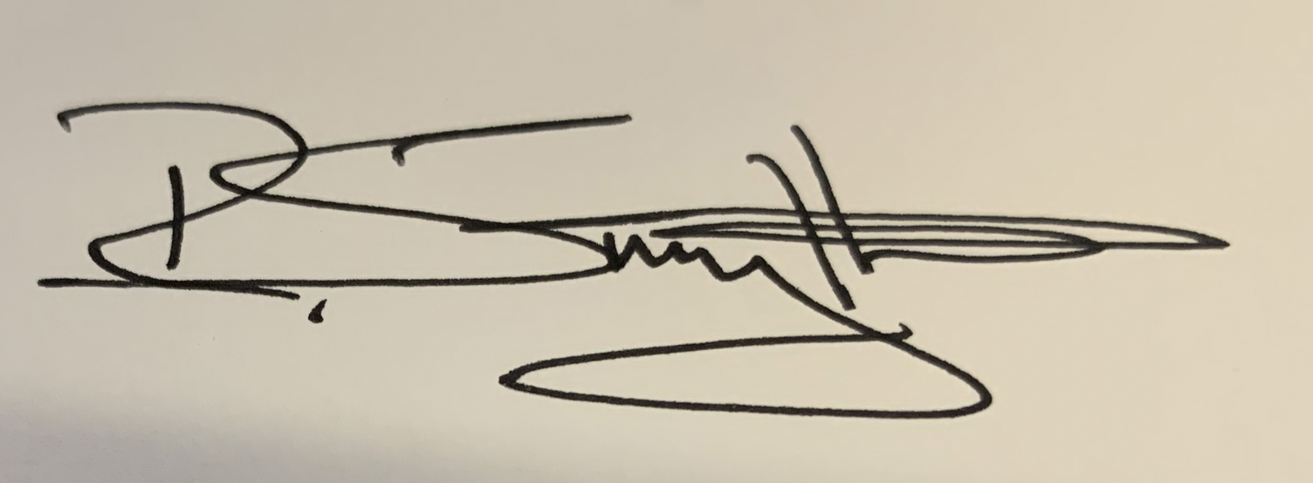

Mr R. Smythe. Clerk.
Dated 24th September 2019.
2 Norton East Road, Cannock, WS11 9RT
PHONE : 01543-448614 E-MAIL : clerk@heathhayes.staffslc.gov.uk
www.hhwpc.co.uk

